United States International University
Brew & Bean Coffee Sales Analysis and Interactive Dashboard Development.
Coffee sales analysis
Ms. Whitney Gituara

Table of Contents
1. Executive Summary 3
2. Introduction 4
Brew & Bean 4
About the Company 4
2.1 Background 4
2.2 Problem Statement 4
2.3 Objectives 4
2.4 Scope 5
3. Dataset Description 6
3.1 Dataset Overview 6
3.2 Data Cleaning and Preparation 6
3.3 Data Model 7
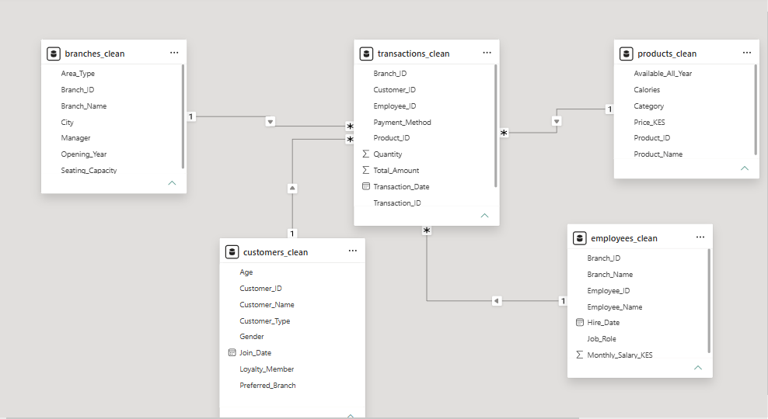 7
4. Methodology 8
4.1 Data Collection 8
4.2 Data Cleaning using Python 9
4.3 Exploratory Data Analysis (EDA) 10
4.4 Power BI Data Modelling 10
4.5 DAX Measures 11
4.6 Dashboard Design 11
5. Dashboard Overview 13
6. Business Insights 15
6.1 Revenue Performance 15
6.2 Branch Performance 15
6.3 Product Performance 15
6.4 Customer Loyalty 15
6.5 Payment Preferences 15
7. Recommendations 16
8. Conclusion 17

1. Executive Summary
This project presents the development of an interactive Power BI dashboard for Brew & Bean Coffee to analyse sales performance and support data-driven decision-making. Using Python, the sales data was cleaned, prepared, and explored before being imported into Power BI for data modelling and visualization.
The dashboard provides insights into key business metrics, including total revenue, transactions, customer count, average sales value, branch performance, product performance, payment methods, and customer loyalty. Interactive visualizations and slicers enable users to explore sales trends and compare performance across different business dimensions.
The analysis revealed that coffee products generated the highest revenue, branch performance remained relatively balanced, and a significant proportion of customers participated in the loyalty programme. The completed dashboard demonstrates how business intelligence tools can transform raw transactional data into meaningful insights that support strategic decision-making.

2. Introduction

Brew & Bean

About the Company
Brew & Bean is a fictional premium coffee shop chain based in Nairobi. The company operates five branches serving handcrafted coffee, pastries, and light meals. While sales have been steadily growing, management lacks clear insights into customer behavior, product performance, and store profitability. They have hired us to transform their sales data into actionable business intelligence.

2.1 Background
The Brew & Bean Coffee Sales Analysis project was developed to demonstrate the complete data analytics lifecycle using Python and Microsoft Power BI. The project focuses on transforming raw transactional coffee shop data into meaningful business insights through data cleaning, exploratory data analysis (EDA), and interactive dashboard development.
The dashboard enables stakeholders to monitor sales performance, customer behavior, branch performance, product popularity, and payment trends through an intuitive visual interface.

2.2 Problem Statement
Coffee shop managers often collect large volumes of transactional data but struggle to transform it into actionable insights. Without effective analysis and visualization, identifying high-performing branches, profitable products, customer loyalty trends, and revenue patterns becomes difficult.
This project addresses that challenge by developing an interactive Power BI dashboard that supports informed decision-making.

2.3 Objectives
The objectives of this project were to:
- Clean and prepare raw sales data using Python.
- Perform exploratory data analysis to understand business trends.
- Build a relational data model in Power BI.
- Create DAX measures for business KPIs.
- Develop an interactive dashboard for sales analysis.
- Present business insights through effective visualizations.

2.4 Scope
The project analyses Brew & Bean sales data covering:
- Sales transactions
- Customers
- Products
- Employees
- Branches
The dashboard focuses on revenue analysis, customer behavior, loyalty, branch performance, product performance, and payment methods.

3. Dataset Description

3.1 Dataset Overview
The Brew & Bean dataset consists of multiple relational tables representing different aspects of the coffee shop's operations. These datasets were generated and cleaned during the data preparation phase before being imported into Microsoft Power BI for analysis.
The project uses the following datasets:
Dataset | Description
Branches | Information about coffee shop branches including location, manager, seating capacity and opening year.
Customers | Customer demographics, loyalty status and customer type.
Employees | Employee information including branch assignment and job role.
Products | Coffee and food products offered by Brew & Bean.
Transactions | Sales transactions including quantity sold, payment method, transaction date and total amount.

3.2 Data Cleaning and Preparation
This section explains the preprocessing steps performed before visualization. Data cleaning was carried out using Python and verified within Power BI.
The following activities were performed:
- Removed duplicate records.
- Checked for missing values.
- Standardized column names.
- Corrected inconsistent data types.
- Converted numeric values stored as text into appropriate numeric formats.
- Created cleaned datasets for analysis.
- Imported the cleaned datasets into Power BI.

3.3 Data Model
The cleaned datasets were imported into Power BI and connected using relationships based on primary and foreign keys. A star-schema-like structure was implemented to enable efficient filtering and aggregation across the dashboard.
A screenshot of the Power BI relationship model is shown below.
Figure 1: Power BI Data Model



4. Methodology
This project followed a structured data analytics workflow consisting of data collection, data preparation, exploratory data analysis, data modelling, DAX measure creation, and dashboard development using Power BI. Python was used for preprocessing and exploratory analysis, while Power BI was used for modelling and visualization.

4.1 Data Collection
The dataset used in this project consisted of transactional sales records from Brew & Bean Coffee. It contained information relating to customer purchases, product details, branch information, payment methods, employees, and customer demographics.
The dataset was imported into Python for preprocessing before being loaded into Microsoft Power BI for modelling and dashboard development.
The primary tables used include:
Table | Description
Transactions | Contains sales transactions including product purchased, quantity, unit price, total amount, payment method and transaction date.
Customers | Stores customer information such as age, gender, customer type and loyalty status.
Products | Contains product names, categories and pricing information.
Branches | Stores branch details including branch name, city, seating capacity and opening year.
Employees | Contains employee information linked to branch operations.
These datasets collectively provided sufficient information to analyse sales performance, customer behavior, product popularity, and branch performance.
The relational nature of the dataset allowed multiple tables to be connected using primary and foreign keys within Power BI, enabling comprehensive business analysis across sales, customers, products and branch performance.

Data Cleaning using Python
Data preprocessing was carried out using Python with the Pandas library to improve data quality before visualization.
The cleaning process involved several stages:
- Handling Missing Values
The dataset was examined for null values. Missing entries were either removed or appropriately handled, depending on the significance of the affected attribute.
- Removing Duplicates
Duplicate records were identified and removed to ensure each transaction was represented only once.
- Data Type Conversion
Several columns contained incorrect data types. Numerical variables such as quantity, unit price, and total amount were converted into numeric formats, while date columns were converted into datetime objects.
- Feature Engineering
Additional variables were generated where necessary to support later analysis. These included derived measures that simplified aggregation during dashboard creation.
- Exporting Clean Data
After preprocessing, the cleaned datasets were exported as CSV files and later imported into Power BI.

Exploratory Data Analysis (EDA)
Exploratory Data Analysis was conducted using Python to understand the characteristics of the dataset before building the dashboard.
The analysis focused on:
- Overall sales distribution
- Product performance
- Customer demographics
- Payment method usage
- Branch performance
- Revenue trends over time
Visualizations such as bar charts, histograms, pie charts, and line graphs were used to identify patterns, detect anomalies, and validate the integrity of the cleaned data.
The findings from the EDA informed the selection of Key Performance Indicators (KPIs) and dashboard visualizations.

Power BI Data Modelling
The cleaned CSV files were imported into Microsoft Power BI Desktop.
A star schema was created by establishing relationships between the tables using primary and foreign keys.
The Transactions table served as the central fact table, while the Customers, Products, Branches, and Employees tables acted as dimension tables.
Relationships were created using:
- Customer_ID
- Product_ID
- Branch_ID
- Employee_ID
The model enabled efficient filtering and aggregation across multiple visuals while maintaining data integrity.

DAX Measures
Data Analysis Expressions (DAX) were used to calculate business metrics required for the dashboard.
The following measures were created:
Measure | Purpose
Revenue | Calculates total sales revenue
Transactions | Counts total transactions
Customers | Counts unique customers
Average Sales Value | Calculates average revenue per transaction
Loyalty % | Calculates the percentage of loyalty customers
Quantity Sold | Calculates total items sold
These measures powered the KPI cards, charts, and summary table displayed on the dashboard.

Dashboard Design
An interactive dashboard was developed in Microsoft Power BI to present key business insights.
The dashboard includes:
- KPI cards showing Revenue, Transactions, Customers, Average Sales Value, and Loyalty Percentage.
- A monthly revenue trend line chart to monitor sales performance over time.
- Revenue by branch visualization to compare branch performance.
- Revenue by product category chart.
- Top five best-selling products chart.
- Payment method distribution donut chart.
- Customer loyalty visualization.
- Interactive slicers for filtering by product category and branch.
- A summary table displaying product-level sales information.
The dashboard was designed using a consistent colour scheme, clear visual hierarchy, and interactive filters to improve usability and support business decision-making.

5. Dashboard Overview
The Brew & Bean Coffee Sales Dashboard was developed to provide an interactive overview of the company's sales performance. It combines key performance indicators (KPIs) with interactive visualizations to help management monitor revenue, customer behavior, branch performance, product sales, and payment preferences.
The dashboard presents business information in a clear and intuitive layout, enabling users to identify trends and compare performance across different business areas. Interactive slicers allow users to filter the dashboard by branch and product category, making the analysis more dynamic and user-friendly.
The dashboard includes the following visualizations:
- KPI cards displaying Total Revenue, Total Transactions, Total Customers, Average Sales Value, and Loyalty Percentage.
- A monthly revenue trend line chart illustrating sales performance over time.
- A bar chart comparing revenue generated by each branch.
- A bar chart showing revenue contribution by product category.
- A chart highlighting the top five revenue-generating products.
- A donut chart displaying payment method distribution.
- A donut chart illustrating customer loyalty membership.
- A summary table showing product-level sales information.
Figure 2: Brew & Bean Coffee Sales Dashboard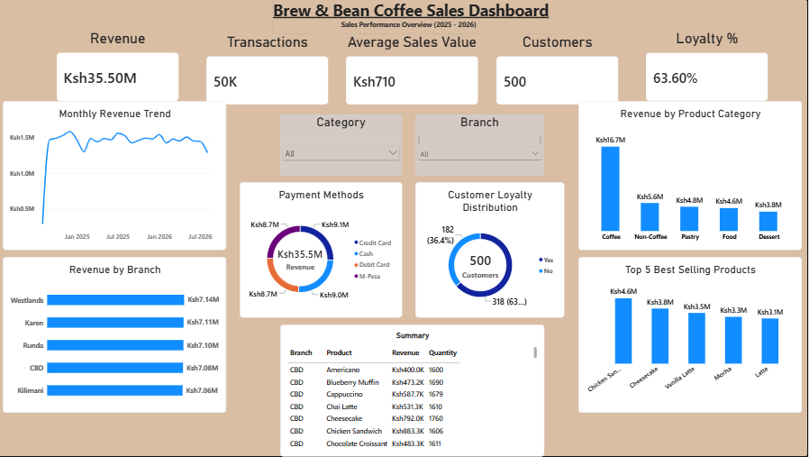

6. Business Insights

6.1 Revenue Performance
The dashboard shows that Brew & Bean generated approximately KES 35.5 million in revenue from 50,000 transactions. The average sales value of approximately KES 710 indicates relatively consistent customer spending throughout the reporting period.

6.2 Branch Performance
Revenue was distributed relatively evenly across the five branches, demonstrating consistent operational performance. Westlands generated the highest revenue, while Kilimani recorded the lowest. Although the differences were relatively small, the results suggest that all branches contributed significantly to the company's overall performance.

6.3 Product Performance
Coffee products generated the largest share of total revenue, making them the strongest-performing product category. The dashboard also highlights the top-performing individual products, allowing management to identify customer favourites and monitor product demand.

6.4 Customer Loyalty
Approximately 63.6% of customers were enrolled in the loyalty programme. This indicates strong customer engagement and repeat business while also highlighting an opportunity to encourage more customers to join the programme.

6.5 Payment Preferences
Customers used Cash, Credit Card, Debit Card, and M-Pesa in relatively similar proportions. This balanced distribution suggests that providing multiple payment options effectively supports customer convenience and purchasing preferences.

7. Recommendations
Based on the analysis presented in the dashboard, the following recommendations are proposed:
- Continue investing in coffee products, as they contribute the highest share of total revenue.
- Expand the loyalty programme through targeted promotions and incentives to encourage repeat purchases.
- Analyse the practices of the highest-performing branches and implement successful strategies across other locations.
- Use the dashboard regularly to monitor sales performance and support data-driven decision-making.
- Review product performance periodically to identify opportunities for introducing new products or improving underperforming categories.

8. Conclusion
This project successfully demonstrates the end-to-end business intelligence workflow using Python and Microsoft Power BI. Sales data was cleaned, analysed, modelled, and transformed into an interactive dashboard that provides meaningful insights into sales performance, customer behavior, branch performance, and product popularity.
The completed dashboard enables stakeholders to monitor key business metrics efficiently, identify trends, and make informed decisions based on reliable data. Overall, the project highlights the value of combining data analytics and visualization tools to transform raw data into actionable business intelligence.

